

Maths Methods 11

2019 Investigation 2

Take Home

Trigonometric Equations and Identities

NAME: _______________________________ Teacher:

Part I

- Graph 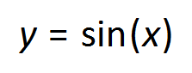 and 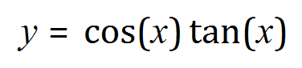over the domain 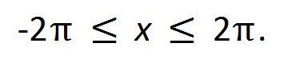Graph the curves on separate grids using the same range and scale. What do you notice?
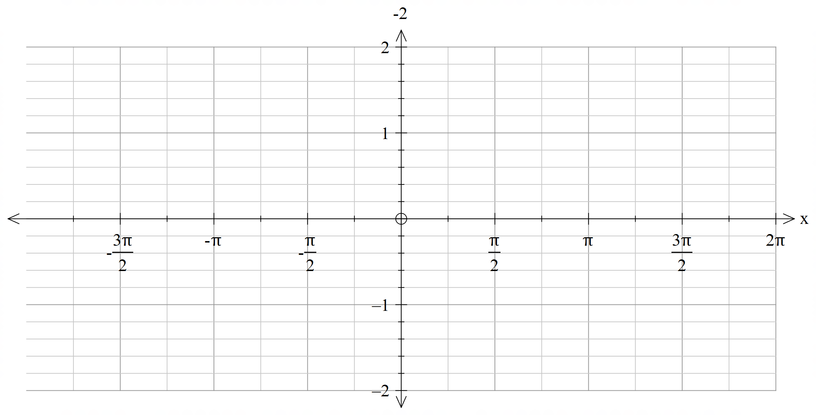



- Make and analyse a table of values for these functions in multiples of 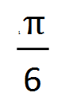 over the domain Describe your findings.

- By examining both the graphs and the table of values, justify whether or not the functions are identical.

- For what values of x will the expressions 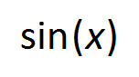 and 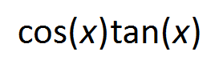 over the given domain, will not be not equal?

Part II

- Consider the equation 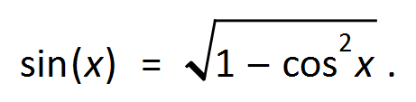

- Identify a value for 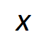 that will make the equation true.

- Identify a value for  that does not work for the equation above.

- Hence provide 2 reasons why the equation above is not an identity.

Part III

Using your results from Part I and Part II, explain the difference between a Trigonometric Equation from an Identity.

